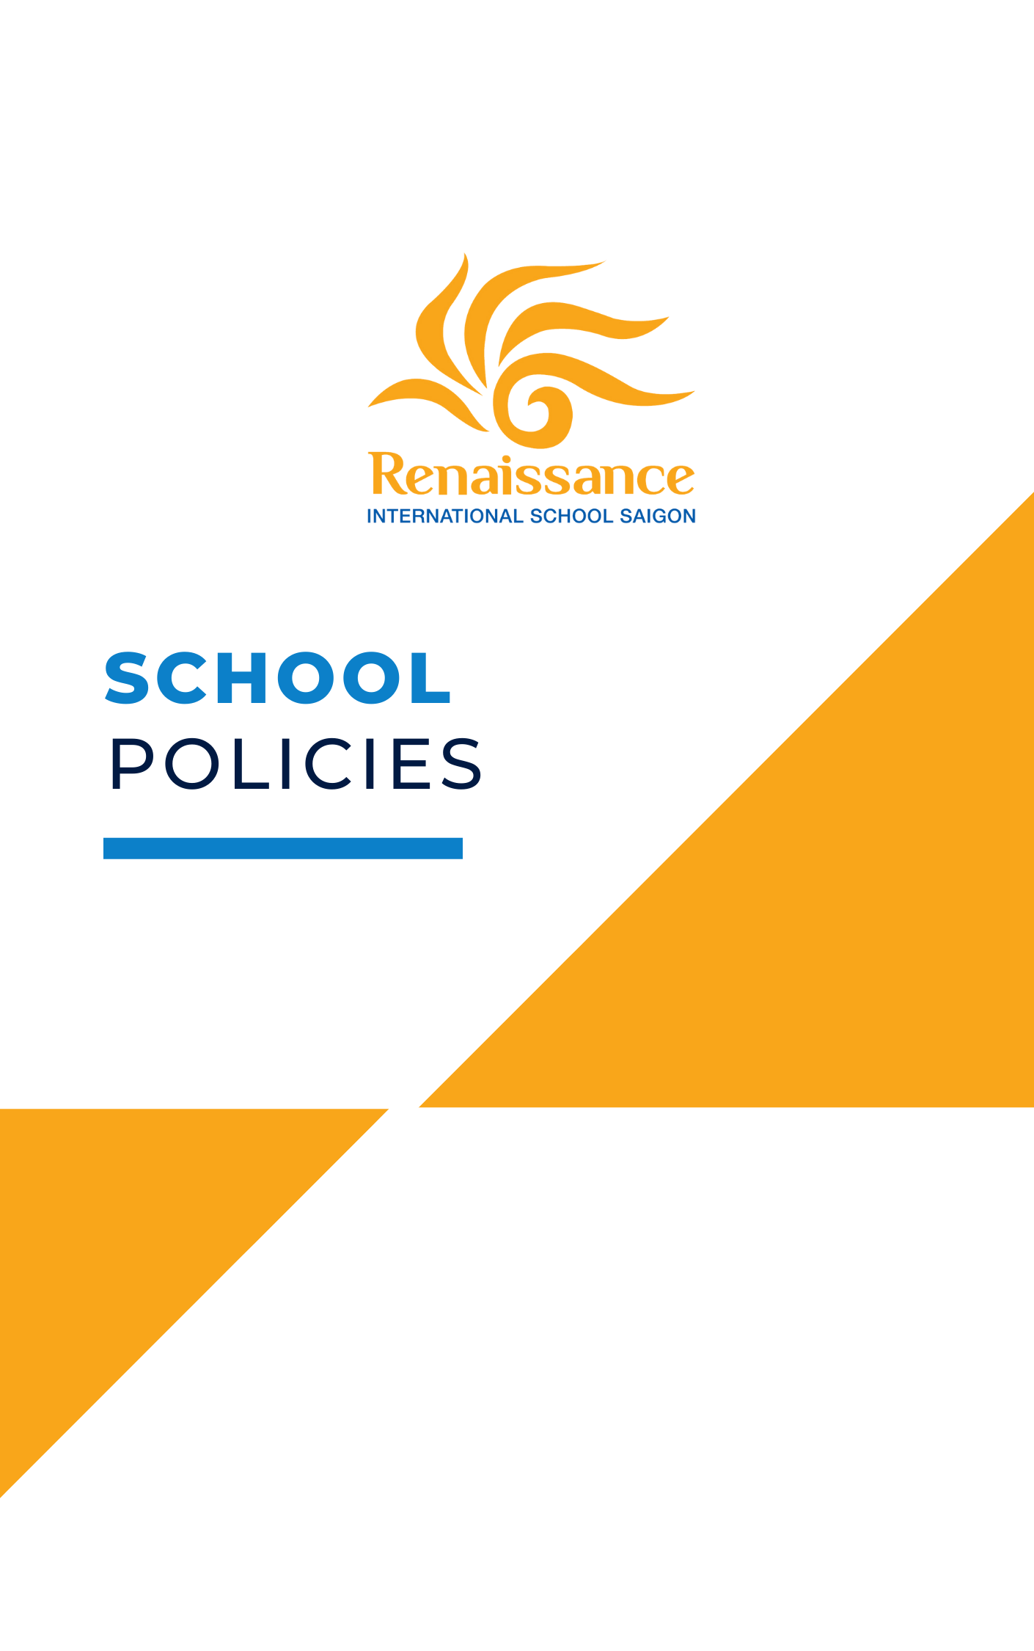

OUR MISSION

As a student – centered, family – focused community, we will guide learners on their journeys towards fulfilling their individual potential, embracing their own independence and internationalism in a safe, supportive and challenging environment.

As a school we have a collective commitment to the Round Square IDEALS – Internationalism, Democracy, Environmentalism, Adventure, Leadership and Service.

OUR VISION

Be happy. Belong. Be excellent.

DEFINITION OF TEACHING AND LEARNING

Excellent teaching and learning takes place in a safe, supportive and challenging environment. Teachers guide learners to fulfill their individual potential, encouraging them to embrace their own independence.

Excellent teaching and learning at Renaissance
- Gives opportunities for students to be creative, take risks and reflect
- Encourages students to be caring and open minded
- Creates confident communicators and collaborators
- Balances knowledge with inquiry skills
- Fosters critical and principled thinking
- Inspires students to challenge themselves

DEFINITION OF INTERNATIONAL MINDEDNESS

We believe that international mindedness is: diversity and commonality; the local and the global; coexisting with disagreement; strength with compassion and a willingness to grow.
We see it as our shared responsibility to be:

Sustainable innovators Local and global collaborators
Tenacious and compassionate problem solvers Multilingual communicators who desire to learn from each other

IB MISSION STATEMENT

The IB develops inquiring, knowledgeable and caring young people who help to create a better and more peaceful world through education that builds intercultural understanding and respect.

The International Baccalaureate® aims to develop inquiring, knowledgeable and caring young people who help to create a better and more peaceful world through intercultural understanding and respect.

To this end the organization works with schools, governments and international organizations to develop challenging programmes of international education and rigorous assessment.

These programmes encourage students across the world to become active, compassionate and lifelong learners who understand that other people, with their differences, can also be right.

LEARNER PROFILE

The International Baccalaureate® (IB) learner profile describes a broad range of human capacities and responsibilities that go beyond academic success.

They imply a commitment to help all members of the school community learn to respect themselves, others and the world around them.

Each of the IB's programmes is committed to the development of students according to the IB learner profile.

The profile aims to develop learners who are:

  - Inquirers
  - Knowledgeable
  - Thinkers
  - Communicators
  - Principled
  - Open-minded
  - Caring
  - Risk-takers
  - Balanced
  - Reflective

Academic Integrity Policy
Early Years - Year 13
Renaissance International School Saigon

PREAMBLE

Academic and personal integrity is an extremely important and fundamental part of education in preparation for future endeavours in schools, universities and workplaces, and as a way of life.

At Renaissance we recognise that the opportunity to learn is limited when work is copied or when someone or something else does the work. We recognise that academic honesty and academic integrity must be demonstrated at all times.

STUDENT RESPONSIBILITIES

All students at Renaissance must:

- understand the principles of knowledge building, and give credit to sources of information or ideas.
- recognise that good ideas are for sharing, but not during individual assessments or exams.
- strive to model the IB learner profile and aim to be principled individuals
- only hand in work that is their own.

Furthermore, students at Renaissance must understand that:

- it is acceptable to use ideas, facts, theories, opinions, statistics, graphics, images and a/v material from someone else as long as you give the author/creator credit.
- when doing research, it is important to keep good records of where the information they will use is located.
- they must tell the truth.
- they must respect others and not interfere with others' learning.
- they must encourage peers to respect the academic honesty policy and never allow others to copy homework, copy on a test, cheat or lie.
- it is OK to accept help from family members, tutors or friends but must never allow others to do the work for them.
- they must use assistive technology, like generative AI, responsibly and must never claim work done by generative AI as their own.
- there are consequences for academic misconduct.
- there are sanctions imposed by the Cambridge International Examinations (CIE) and the International Baccalaureate Organization (IBO).
- the consequences for academic misconduct can be very serious and affect future academic or work opportunities.

It is recommended that students keep all rough notes and drafts that they produce in order to be able to refute any possible charges of academic misconduct.

What help can students expect from teachers?

Teachers at Renaissance will:

- help students understand that academic integrity is in their best interests.
- teach how to locate and use information and a/v material from print and the internet ethically and responsibly by referencing and citing sources in an age-appropriate manner.
- ask to see working drafts of student work to confirm it is their own and provide guidance early in the inquiry process if problems arise.
- provide access to plagiarism software for secondary students to submit assignments.
- respond appropriately to suspected incidences or reports of academic misconduct.
- ensure that students understand the school academic honesty policy and procedures in cases of suspected academic misconduct.
- model exemplary behaviour and high standards of Academic Integrity at all times.

What help can students expect from the school?

The school will:

- maintain a school climate that allows for the values of integrity, honesty, fairness and justice to thrive.
- implement and monitor strict procedures during exam times to prevent academic misconduct.
- provide time and opportunity for teachers to collaborate and work with the teacher-librarian to teach referencing and citation skills to students.
- promote parental awareness of the school’s academic honesty policy.
- provide Turnitin online originality checking software for staff and student use.
- provide guidance for teachers and students in the ethical use of generative AI and assistive technology.

What is the role of parents, family and tutors?

It is helpful for parents, family and tutors to:
- support and guide students with home learning
- help students ensure that the home learning and completed work, is owned, and completed, by the student, not an adult/helper.
- take joint responsibility for the authenticity of any school assignment on which they work together.
- understand that the tutor’s role is only to comment on the student’s ideas and written work. Any assignment which is judged to be more the work of the tutor than of the student is unacceptable.

What measures will be taken to provide education and support?

The teacher-librarian will provide guidance, instruction and on-going support for referencing and citations in an age-appropriate manner. He/she will also provide instruction on locating reliable sources of information, using images and a/v materials ethically, advise on copyright and use of "creative commons" licensed materials.

What are examples of age-appropriate referencing when using information or ideas of others in schoolwork?

These guidelines apply to schoolwork presented in print, in electronic presentations such as PowerPoint presentations, videos or through any other means.

Referencing should be done with increasing detail from Years 1-13:

Year 1-2 - e.g., Bibliography page at the end of an inquiry project including:
- Names of people who helped
- Titles of Books and/or Websites

Year 3-4 -e.g., Bibliography page to include:
- Names of people who helped
- Author, Title of books and/or websites

Year 5-6 - e.g., Correct use of quotations to show direct quotes in written reports.
Bibliography page for all research and presentations to include:
- Names of people who provided ideas/information
- Author(s), Title of book/website/image, Publisher and Date of publication

Year 7-9 - e.g., Correct use of quotations and citations to show direct quotes in written reports. For all assignments including work submitted or shown through electronic means, a bibliography is prepared according to Modern Language Association (MLA9) standard and includes:
- Names of people who provided ideas/information
- Author(s), Title of book/website/image, Publisher, Place of Publication, Date of Publication, URL, date of access.

Years 10-13 – e.g.
- Accurate use of quotations to show direct quotes, MLA8 labelling of images, tables, graphs and appendices
- In-text citations show where information and ideas from others has been included
- Full Works Cited page AND in-text citations are according to Modern Language Association (MLA9) standard (or another standard agreed upon by student and teacher/supervisor)

What are examples of Academic Integrity in practice?

Year 1-2
- When students are being assessed for individual understanding, they sit apart and cover their answers so others cannot see.
- Students produce a bibliography page listing titles of books and websites for all inquiry projects.
- Students recognize the concept of ownership by identifying authors of stories.

Year 3-4
- When working in small groups to complete a project, each member contributes to the learning and final product.
- They include a bibliography page listing all those who helped them, along with authors and titles of books or websites where information was found.

Year 5-6
- A student cannot understand a question on a test, but instead of copying from his/her neighbour, leaves it blank. That way the teacher knows that he/she needs extra help and review instead of more challenging work.
- Students include a bibliography section at the end of an assignment listing all the books and websites they used to complete a project on inventions.

Years 7-9
- A student cannot understand maths home learning, so asks his brother or sister to complete it for him/her. Instead of doing it for him/her, the sibling sits down and shows how to solve the maths problems. The next day the student tells the teacher he/she got help with home learning.
- Students use "mybib" to prepare a formatted list of references according to the MLA9 standard and copy it to the "Credits" page in video editing software when producing a video on their history project.

Years 10-13
- Students adhere strictly to the directions provided by examiners during all examinations.
- Students provide in-text citations and a full list of references when preparing presentations, videos and essays.
- Students may use generative AI to support their idea generation process but understand the importance of producing their own writing and thinking.

Frequently Asked Questions:

Can I use referencing tools to prepare my list of references/Works Cited pages?

There are several online tools that will help format the list of references/Works Cited pages such as:
- bibme.org
- easybib.com
- citationmachine.net
- mybib.com

The reference tools in Microsoft Word are also handy to keep track of sources of information, insert citations, and prepare the final Works Cited list.

What constitutes academic misconduct?

The following is adapted from the "A8.1 Academic Honesty", Handbook of procedures for the Diploma Programme, 2014 & “Academic Integrity” IBO 2019

Lack of referencing - Referencing other's ideas or a/v material is expected in all work submitted for assessment including audio-visual presentations, text, graphs, images and work produced in print or electronically.

Failure to do so is known as plagiarism.

Renaissance school advises students to acknowledge the sources of all information in the style as outlined by Modern Language Association (MLA8).

- All Year 1-9 students are expected to provide a list of references formatted in an age-appropriate manner and with increasing detail as they graduate through the years.

- All Year 10-13 students are expected to provide both a list of fully formatted references as well as citations clearly indicating where the references are used in all their work.

Too much assistance - Students must be cautious when receiving help from family, tutors or homework help/services that they do not receive so much assistance that the work submitted is no longer their own.

Misuse of Generative AI – Students must also be cautious of submitting work created with the assistance of generative AI. Renaissance students are principled and understand the lack of integrity in using AI to avoid work that would impact their learning process. However, students know that Generative AI may be used if properly referenced, and if it assists the student in showing their work and originality.

Collusion- Collusion is helping another student to be academically dishonest. Examples include communicating with another candidate in a text or exam, allowing others to copy homework, doing the work for another, or doing a disproportionate amount of work in group projects. Another example is a parent fabricating an excuse for their child.

Other Forms - Other behaviours that constitute academic misconduct include for example: handing in the same assignment for more than one assessment, fabricating data, taking unauthorised material into an examination room, creating a distraction during an exam, impersonating another for the purpose of taking an exam or stealing examination papers or any other behaviour that gives an unfair advantage.

What is the difference between collusion and legitimate collaboration?

Collusion is an illegal and unethical practice where two or more students collude to cheat or deceive in order to gain advantage. It entails deception, misrepresentation, and fraud. Examples of collusion include cheating on tests, copying someone else’s work, or agreeing to give false information.

Legitimate collaboration, on the other hand, is educational collaboration where individuals work together to produce the best possible outcome. It involves selecting topics, researching, discussing ideas, and creating joint solutions. Legitimate collaboration is based on an ethical code of collaboration, fairness, and respect for individual ideas. It is also encouraged by teachers and universities.

What are some examples of Academic Misconduct?

- plagiarism (not providing a reference or citation for ideas, images, information or a/v materials)
- copying answers during an individual assessment or exam
- allowing others to copy your answers during an individual assessment or exam or otherwise helping another student(s) commit academic misconduct
- asking a teacher to change your grade without offering to do more work
- allowing a tutor, family member or anyone else to do the work for you
- writing answers on the table or your hand
- using tools you are not supposed to when you are not supposed to (e.g., calculator or generative AI)
- copying and pasting from the internet or generative software without thinking about the information or rephrasing the information

What are the procedures for dealing with Academic Misconduct?

The most immediate consequence of academic misconduct is that the student's ability to learn and grow academically is compromised. All efforts are made to ensure that the student understands why academic integrity is important and learns the attitudes, skills and behaviours to do their own work and reference their sources of information.

Incidences of non-intentional academic misconduct will be dealt with restoratively in one or more of the following ways:

- the teacher and student will discuss why it is important to do their own work
- the student will re-do and resubmit the work
- the teacher or teacher-librarian will provide individual instruction on why and how to reference sources of information

Minor incidences of academic misconduct can be resolved between the student and their teacher and/or form tutor and Key stage leader. If a member of staff suspects that a student has made a serious breach of the school Academic honesty policy, they will inform a member of the Senior Leadership Team who will determine whether to conduct a confidential investigation.

Teachers may be asked to collaborate with each other to assess whether there is suspected academic misconduct. If so, the student will be informed and given the chance to reply to the accusation with the right to request a parent, peer or teacher present during this meeting.

Early Years - Year 13
Sanctions will be imposed in an age-appropriate manner, will depend upon the seriousness of the violation, and whether it is a repeated violation.

There are very serious consequences for academic dishonesty imposed by CIE and the IBO. Both exam boards expect teachers to support students to produce work in-line with the relevant academic integrity policies. Any issues of academic integrity, including failure to reference and cite sources appropriately, to be dealt with in-house following Renaissance’s policy before submission of work. If CIE or IBO find that students have submitted plagiarised or dishonestly produced academic work, they will initiate their own investigation, which will be supported by the Head of Secondary, the examinations officer at Renaissance and relevant teachers. If students are suspected of academic dishonesty during an examination, the invigilators of the exam will complete a report to send to the exam board. The examination board will determine the outcome.

Engagement

Primary Students
This policy will be introduced to the primary students in a scaffolded, age-appropriate language embedded in the information science or library classes.

Secondary Students
For MYP students, students will be given access to this policy at the beginning of year 7. The students must confirm that they have read and understood this policy on an online form. The policy will remain accessible in their year group team.

FOR IGCSE & IBDP students, this policy will be printed in their student handbook. This handbook will also be available electronically in their year group Team. Students will be required to confirm that they have read and understood this policy on an online form at the start of years 10 & 12.

Date of Policy: April 2022

Date of Review: February 2023

Reviewed: March 2023

Sources of Information:
“Academic Honesty” International Baccalaureate Organization, 2019

"A8.1 Academic Honesty." Handbook of Procedures. International Baccalaureate Organization, 2014. Web. 22 Nov. 2014.

"Academic Honesty." Parent Handbook 16.2 (2013): Straits International School: Penang, Malaysia. 2013. Web.

International Baccalaureate Organization. OCC _academic honesty in the IB
educational context. International Baccalaureate Organization: UK, August 2014.

